TITLE: ML LAB – 12: Fraud Detection under Concept Drift using Machine Learning
Student Name: Mahir Desai
Roll No: 23FE10CSE00345
------------------------------------------------
AIM
Build a robust, end-to-end ML pipeline for detecting fraudulent transactions in highly imbalanced, temporally evolving data, evaluating with Precision-Recall AUC (PR-AUC) and utilizing SHAP for explainability.
------------------------------------------------
1. Overview
Financial fraud detection is a high-stakes classification problem where traditional accuracy metrics fail due to extreme class imbalance (~1.5% fraud rate). This project addresses severe class imbalance, concept drift over time, and the need for explainable predictions. The pipeline focuses on maximizing PR-AUC using an XGBoost model.
2. Dataset Details
- Source: Synthetic financial transaction dataset
- Size: ~6.3 million transactions
- Imbalance Ratio: ~66:1 (Legitimate vs. Fraud)
- Target Variable: isFraud (binary)
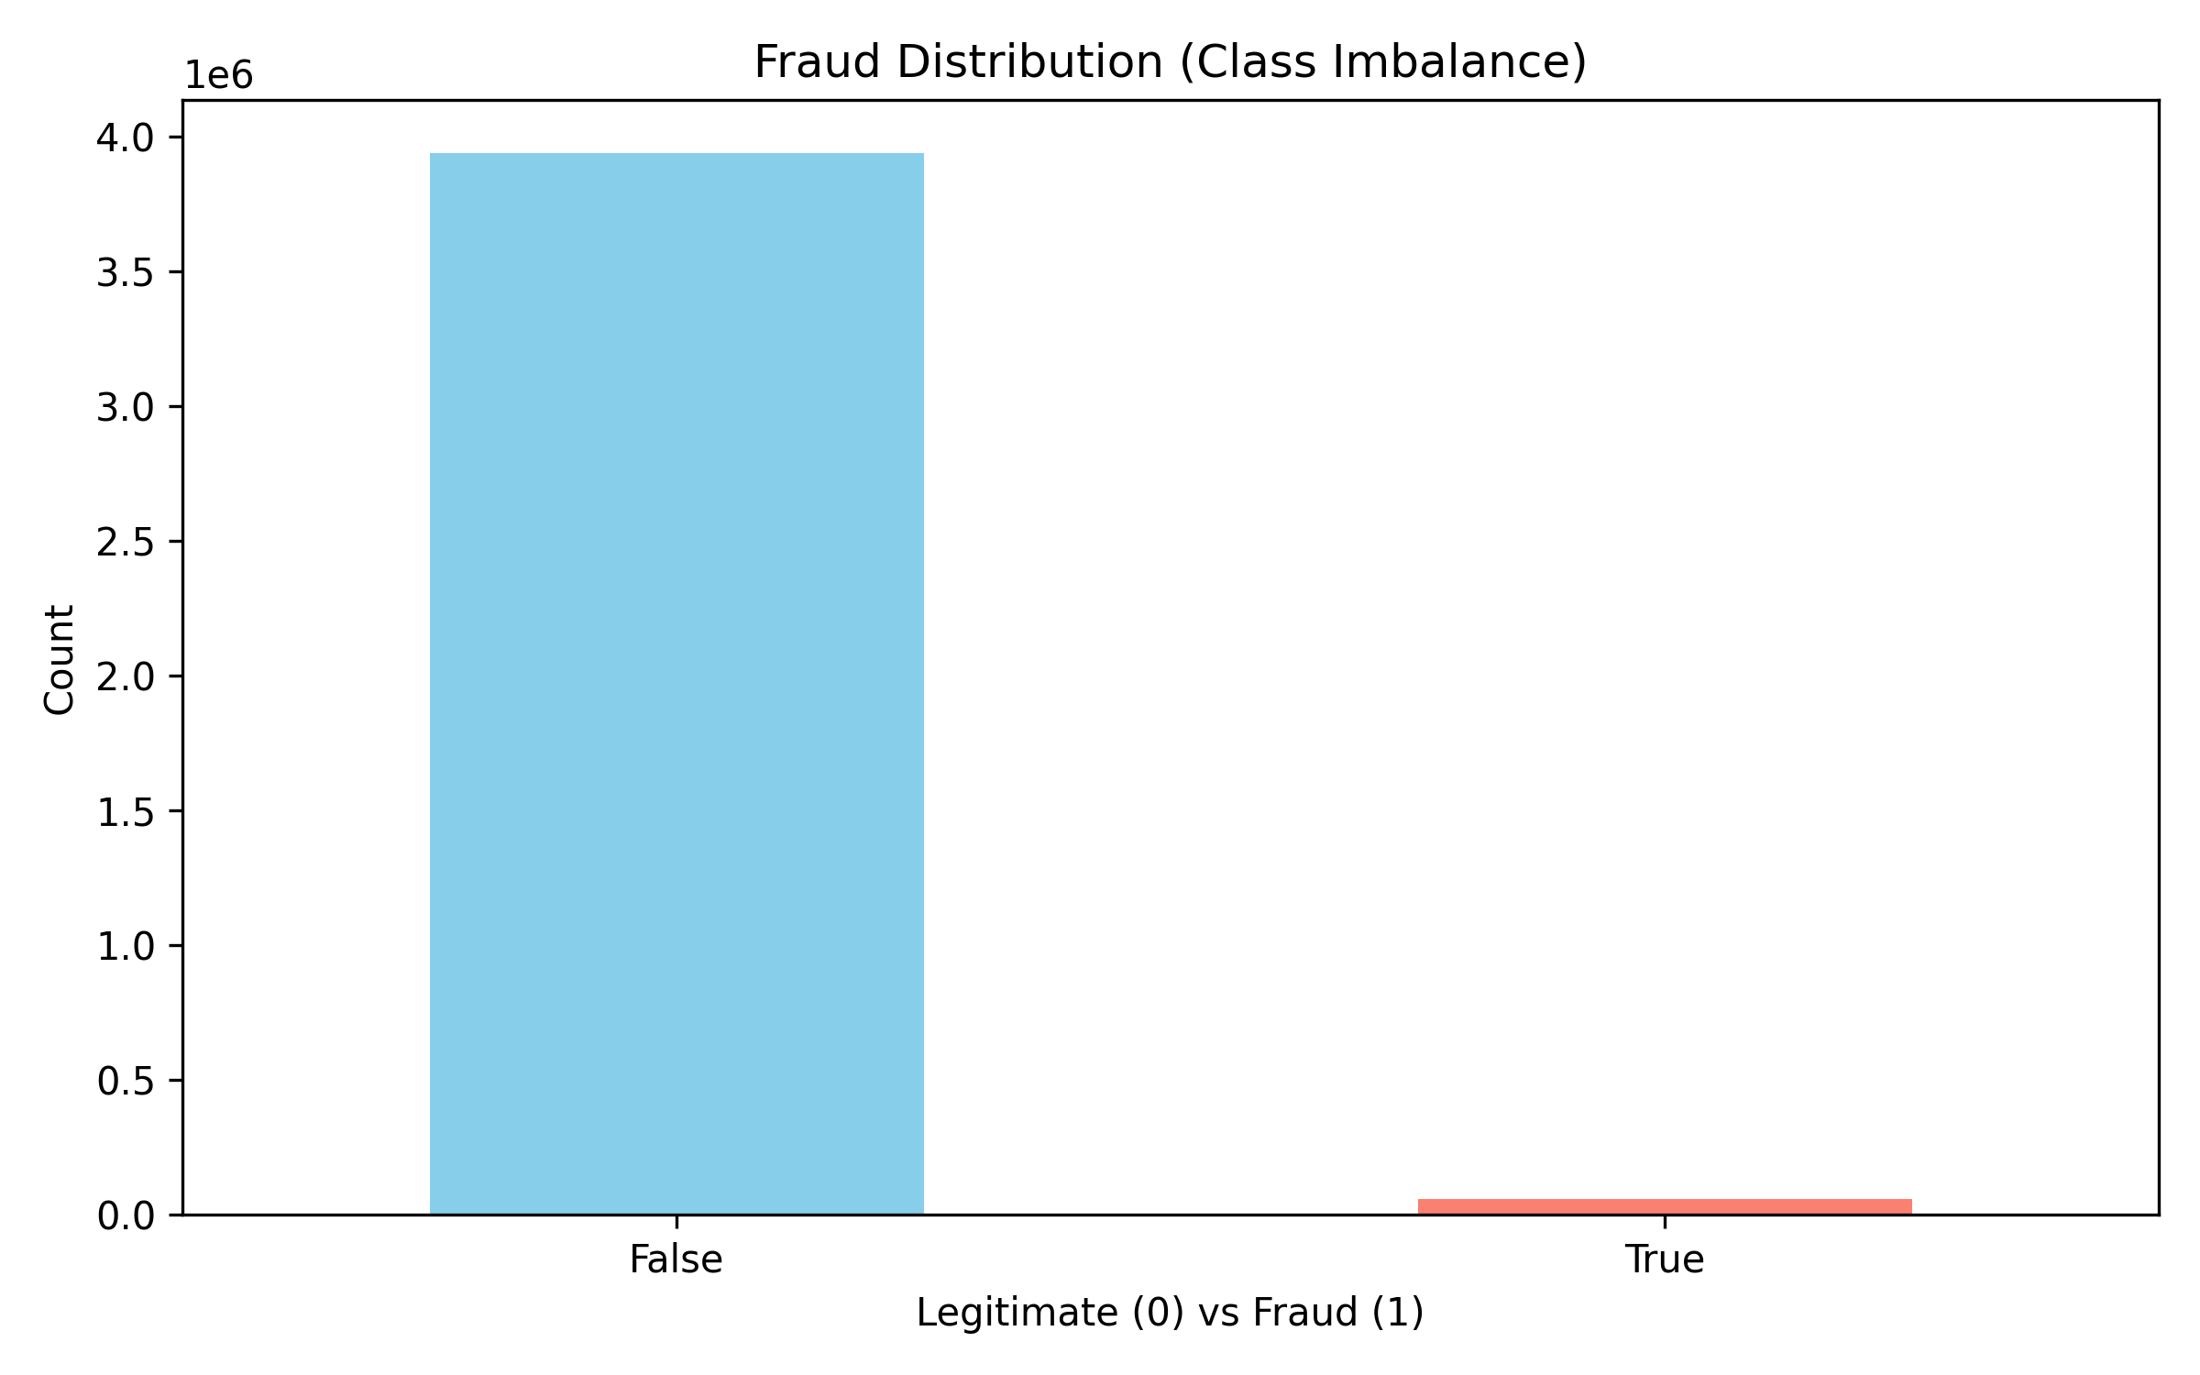
3. Approach and Pipeline
1. Feature Engineering: Added temporal and behavioral features.
2. Validation Split: Temporal 60/20/20 split to avoid data leakage.
3. Base vs Advanced Models: Compared Logistic Regression, Decision tree, and Random Forest vs XGBoost.
4. Hyperparameter Tuning: GridSearchCV to optimize PR-AUC.
5. Threshold Optimization: Shifting decision threshold from 0.5 to balance precision and recall cost.
6. Explainability: SHAP analysis for feature contribution.
4. Results - Model Comparison
Precision-Recall Curves demonstrate XGBoost's clear dominance across all recall levels, achieving a 12x improvement over baseline (~0.19 PR-AUC).
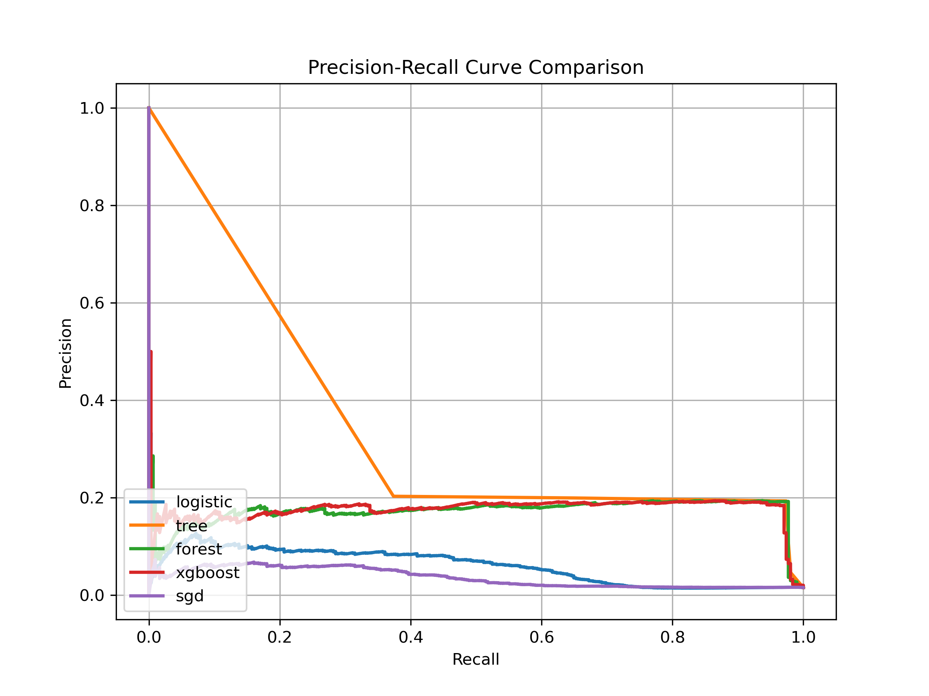
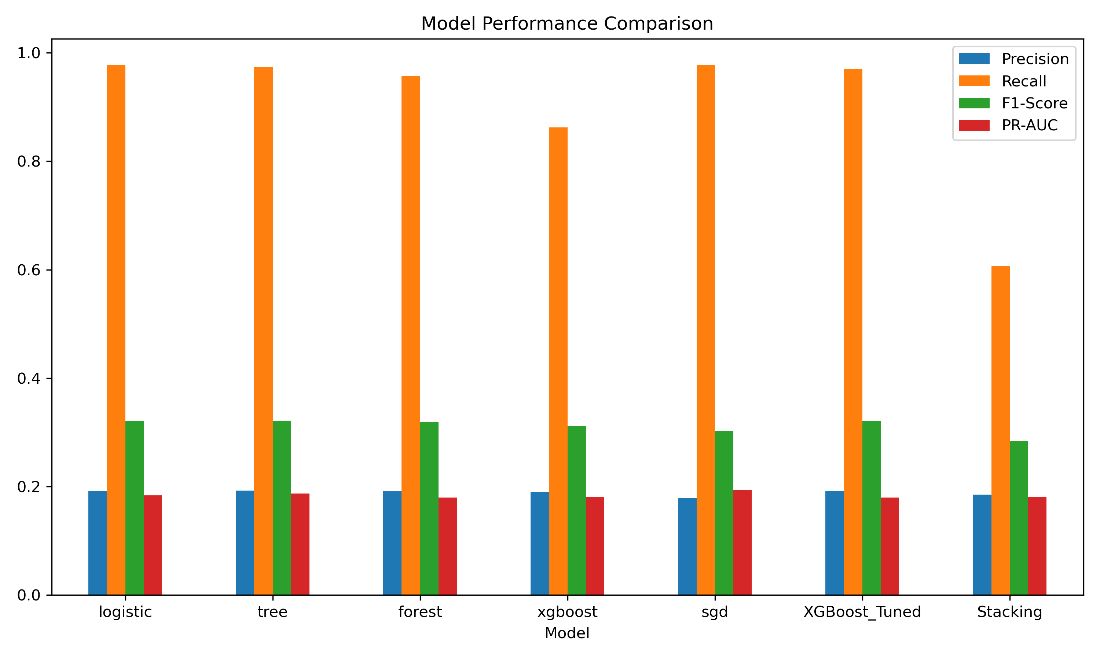
5. Feature Importance & Explainability
SHAP (SHapley Additive exPlanations) highlights that transaction amount and balance delta features are the strongest fraud indicators.
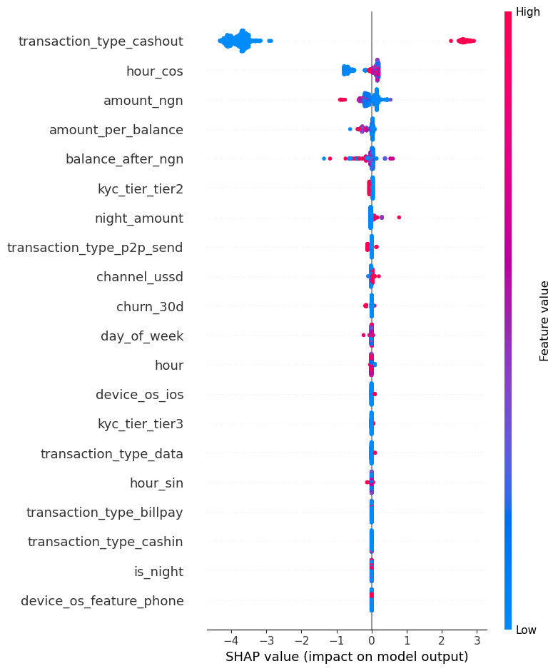
------------------------------------------------
Key Takeaways:
- Accuracy is misleading for imbalanced data. PR-AUC provides an honest representation of minority class detection capability.
- Models must be monitored and retrained periodically because Concept Drift is measurable and causes feature relevance to fluctuate over time.
- Cost-sensitive classification thresholds are necessary as false negative costs heavily outweigh false positive operations.

